DEALING WITH WORKPLACE
BULLYING - A WORKER’S GUIDE
May 2016
Safe Work Australia is an Australian Government statutory agency established in 2009. Safe Work Australia consists of representatives of the Commonwealth, state and territory governments, the Australian Council of Trade Unions, the Australian Chamber of Commerce and Industry and the Australian Industry Group.
Safe Work Australia works with the Commonwealth, state and territory governments to improve work health and safety and workers’ compensation arrangements. Safe Work Australia is a national policy body, not a regulator of work health and safety. The Commonwealth, states and territories have responsibility for regulating and enforcing work health and safety laws in their jurisdiction.

ISBN 978-1-74361-241-5 [PDF]
ISBN 978-1-74361-242-2 [DOXC]

Creative Commons
Except for the logos of Safe Work Australia, SafeWork SA, WorkSafe Tasmania, WorkSafe WA, Workplace Health and Safety QLD, NT WorkSafe, SafeWork NSW, Comcare and WorkSafe ACT, this copyright work is licensed under a Creative Commons Attribution-Noncommercial 3.0 Australia licence. To view a copy of this licence, visit
http://creativecommons.org/licenses/by-nc/3.0/au/
Generally, you are free to copy, communicate and adapt the work for non commercial purposes,
as long as you attribute the work to Safe Work Australia and abide by the other licence terms.
Contact information
Safe Work Australia
Email: info@swa.gov.au
Website: www.swa.gov.au

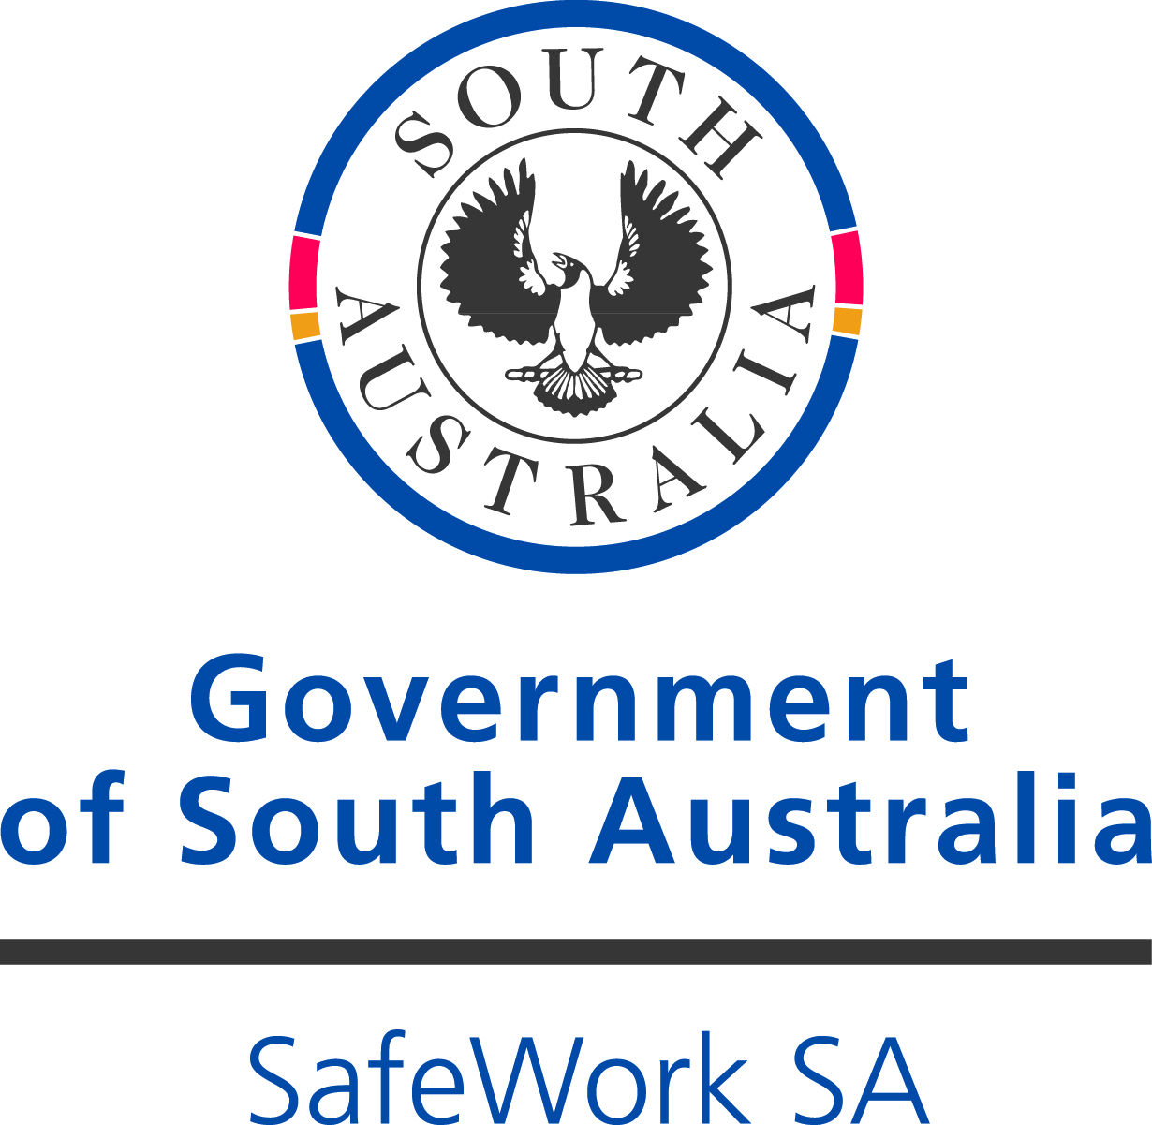

TABLE OF CONTENTS
DEALING WITH WORKPLACE BULLYING - A WORKER’S GUIDE 1
TABLE OF CONTENTS 3
1 INTRODUCTION 4
1.1. What is workplace bullying? 4
1.2. What is not workplace bullying? 5
Reasonable management action taken in a reasonable way 5
Unlawful discrimination and sexual harassment 6
Workplace conflict 6
1.3. How can workplace bullying occur? 6
1.4. Impact of workplace bullying 7
2 WHAT CAN YOU DO? 8
2.1. Are you experiencing or witnessing workplace bullying? 8
2.2. Next steps if the behaviour does not appear to be workplace bullying 8
2.3. Next steps if the behaviour does appear to be workplace bullying 9
Refer to your workplace policies and procedures 9
Speak to the other person 9
Seek advice 9
Report it 10
2.4. What to do if you are accused of workplace bullying 10
Give the complaint serious consideration 10
Seek an objective opinion about the behaviour 10
Adjust unreasonable behaviour 11
3 WHAT SHOULD YOU EXPECT FROM YOUR WORKPLACE? 12
4 WHERE CAN YOU GO FOR HELP? 13
Work Health and Safety Regulators 13
Fair Work Commission 14
Human Rights and anti-discrimination agencies 14
Support services 15

- INTRODUCTION
Workplace bullying is a risk to health and safety because it may affect the mental and physical health of workers. Failure to take steps to manage the risk of workplace bullying can result in a breach of Work Health and Safety (WHS) laws.
Everyone at the workplace has a work health and safety duty and can help to prevent workplace bullying. Under WHS laws, while at work, workers must take reasonable care that their behaviour does not adversely affect the health and safety of other persons. Workers must also comply, so far as is reasonably practicable, with any reasonable instruction given by the person conducting the business or undertaking (PCBU) and co-operate with reasonable policies and procedures of the PCBU that the worker has been notified of, such as a workplace bullying policy.
This guide is intended to help workers determine if workplace bullying is occurring and how to prevent and deal with it. It provides information for workers who may be experiencing or witnessing workplace bullying and for those who have had a bullying report made against them.
This is the second version of this guide. It will continue to be revised as strategies for preventing and dealing with workplace bullying evolve.
  - What is workplace bullying?
Workplace bullying can adversely affect the psychological and physical health of a person. Workplace bullying is a psychological hazard that has the potential to harm a person, and it also creates a psychological risk as there is a possibility that a person may be harmed if exposed to it. If effective control measures are put in place to address and resolve workplace issues early, a workplace can minimise the risk of workplace bullying and prevent it from becoming acceptable behaviour in the workplace.
Workplace bullying is repeated and unreasonable behaviour directed towards a worker or a group of workers that creates a risk to health and safety.
Repeated behaviour refers to the persistent nature of the behaviour and can involve a range of behaviours over time.
Unreasonable behaviour means behaviour that a reasonable person, having considered the circumstances, would see as unreasonable, including behaviour that is victimising, humiliating, intimidating or threatening.
Not all behaviour that makes a person feel upset or undervalued at work is workplace bullying. Examples of behaviours, whether intentional or unintentional, that may be workplace bullying if they are repeated, unreasonable and create a risk to health and safety include, but are not limited to:
- abusive, insulting or offensive language or comments
- aggressive and intimidating conduct
- belittling or humiliating comments
- victimisation
- practical jokes or initiation
- unjustified criticism or complaints
- deliberately excluding someone from work-related activities
- withholding information that is vital for effective work performance
- setting unreasonable timelines or constantly changing deadlines
- setting tasks that are unreasonably below or beyond a person’s skill level
- denying access to information, supervision, consultation or resources to the detriment of the worker
- spreading misinformation or malicious rumours, and
- changing work arrangements, such as rosters and leave, to deliberately inconvenience a particular worker or workers.
If the behaviour involves violence, for example physical assault or the threat of physical assault, it should be reported to the police.
  - What is not workplace bullying?
A single incident of unreasonable behaviour is not workplace bullying however, it may be repeated or escalate and so should not be ignored.

Reasonable management action taken in a reasonable way
It is reasonable for managers and supervisors to allocate work and give feedback on a worker’s performance. These actions are not considered to be workplace bullying if they are carried out in a lawful and reasonable way, taking the particular circumstances into account. A manager exercising their legitimate authority at work may result in some discomfort for a worker. The question of whether management action is conducted in a reasonable way is determined by considering the actual management action rather than a worker’s perception of it, and where management action involves a significant departure from established policies or procedures, whether the departure was reasonable in the circumstances.
What is reasonable would be determined by an objective test through a court of law. However, a court could consider the following examples as reasonable management action:
- setting realistic and achievable performance goals, standards and deadlines
- fair and appropriate rostering and allocation of working hours
- transferring a worker to another area or role for operational reasons
- deciding not to select a worker for a promotion where a fair and transparent process is followed
- informing a worker about unsatisfactory work performance in an honest, fair and constructive way
- informing a worker about unreasonable behaviour in an objective and confidential way
- implementing organisational change or restructuring, and
- taking disciplinary action including suspension or termination of employment where appropriate or justified in the circumstances.

Unlawful discrimination and sexual harassment
Unreasonable behaviour may involve unlawful discrimination or sexual harassment which in isolation is not bullying.
Discrimination on the basis of a protected trait in employment may be unlawful under anti-discrimination, equal employment opportunity, workplace relations and human rights laws.
Generally, unlawful discrimination is where a person or group of people are treated unfairly or less favourably than others because they have a particular characteristic or belong to a particular group of people. Protected traits include race, colour, sex, sexual orientation, age, physical or mental disability, marital status, family or carer’s responsibilities, pregnancy, religion, political opinion, national extraction or social origin. For example, it would be unlawful for an employer not to employ or promote a woman because she is pregnant or may become pregnant.
The WHS Act prohibits a person from engaging in ‘discriminatory conduct’ for a ‘prohibited reason’. For example, it is unlawful for a person to terminate the employment of a worker for raising health and safety concerns or performing legitimate safety-related functions in relation to their workplace.
Generally, sexual harassment includes unwelcome sexual advances, requests for sexual favours or other unwelcome conduct of a sexual nature that could be expected to make a person feel offended, humiliated or intimidated.
Advice and assistance on how to deal with discrimination or sexual harassment can be provided by:
- the Australian Human Rights Commission
- the Fair Work Commission
- state and territory anti-discrimination, equal opportunity and human rights tribunals.
Contact details are provided in Chapter 4.

Workplace conflict
Differences of opinion and disagreements are generally not workplace bullying. People can have differences and disagreements in the workplace without engaging in repeated, unreasonable behaviour that creates a risk to health and safety. However, in some cases, conflict that is not managed may escalate to the point where it becomes workplace bullying.
If workplace conflict is affecting you, you should raise your concerns with your manager, supervisor, human resources officer or grievance officer.
  - How can workplace bullying occur?
Workplace bullying can be carried out in a variety of ways including through verbal or physical abuse, through email, text messages, internet chat rooms, instant messaging or other social media channels. In some cases workplace bullying can continue outside of the workplace.
Workplace bullying can be directed at a single worker or group of workers and be carried out by one or more workers. It can occur:
- sideways between workers
- downwards from supervisors or managers to workers, or
- upwards from workers to supervisors or managers.
Workplace bullying can also be directed at or perpetrated by other people at the workplace, for example clients, patients, students, customers and members of the public.
  - Impact of workplace bullying
Workplace bullying can be harmful to the person experiencing it and to those who witness it, although the effects will vary depending on individual characteristics as well as the situation and may include one or more of the following:
- distress, anxiety, panic attacks or sleep disturbance
- physical illness, for example muscular tension, headaches, fatigue and digestive problems
- reduced work performance, concentration and decision making ability
- loss of self-esteem and self-confidence
- feelings of isolation
- deteriorating relationships with colleagues, family and friends
- depression, and
- thoughts of suicide.

- WHAT CAN YOU DO?
  - Are you experiencing or witnessing workplace bullying?
To be able to take the most appropriate action it is important to first establish whether the behaviour you are experiencing or witnessing is workplace bullying. Below are some questions that you could consider to determine if certain behaviour amounts to workplace bullying.
Is the behaviour being repeated?
Repeated behaviour refers to the persistent nature of the behaviour and can involve a range of behaviours over time.
If it is a one-off incident of unreasonable behaviour, it is not workplace bullying.
Is the behaviour unreasonable?
Unreasonable behaviour means behaviour that a reasonable person, having considered the circumstances, would see as unreasonable including behaviour that is victimising, humiliating, intimidating or threatening.
If you answer yes to these questions and you consider that your health and safety is being impacted as a result (for example, in one of the ways outlined in Chapter 1.4), you may be experiencing or witnessing workplace bullying. There are circumstances when perceived unfair treatment can actually be a result of miscommunication. It can be difficult in times of stress to be objective about what is happening. Therefore, in considering the questions above, it may be helpful to seek the perspective of another person who is not involved, if you need extra support, you can discuss the situation with a human resources officer, health and safety representative (HSR) or union representative.
If you are experiencing or witnessing any behaviour that involves violence, for example physical assault or the threat of physical assault, it should be reported to the police.
  - Next steps if the behaviour does not appear to
be workplace bullying
If you remain upset or unhappy because of the behaviour, you could seek advice on strategies that may help resolve the situation and how you are feeling. For example, if the behaviour was reasonable management action or a one-off incident but it still seems unreasonable to you, you could raise your concerns with the person directly or with your supervisor, manager or human resources officer. If necessary, conflict resolution, mediation or counselling services may assist in resolving the issue.
If you believe the behaviour involves unlawful discrimination or sexual harassment, you can seek advice and assistance from your union representative, the Australian Human Rights Commission, your relevant State or Territory anti-discrimination, equal opportunity or human rights tribunals, the Fair Work Commission, or seek legal advice.
You should continue to monitor the situation over time to ensure it does not escalate to workplace bullying.
  - Next steps if the behaviour does appear to be workplace bullying

Refer to your workplace policies and procedures
Check whether your workplace has a bullying policy and reporting procedure. The policy should outline how the organisation will prevent and respond to workplace bullying.
Your supervisor, manager or human resources officer should be able to tell you whether there are relevant policies in place. Information on your workplace bullying policy may also be provided in:
- induction information, awareness sessions, in-house newsletters or displayed on notice boards
- documents such as a ‘code of conduct’, or
- discussions at staff meetings and in team briefings.

Speak to the other person
If you feel safe and comfortable doing so, calmly tell the other person that you object to their behaviour and ask that it stop. They may not realise the effect their behaviour is having on you or others, and your feedback may give them the opportunity to change their actions. You may also consider suggesting an alternate way for them to behave that is acceptable to you, however whether this is appropriate will depend on the circumstances.
If you choose to deal with the situation personally you should consider:
- acting as early as possible
- raising your concerns informally and in a non-confrontational manner
- not engaging in retaliatory behaviour
- focusing on the unwanted behaviour and how it makes you feel, rather than the person, and
- being open to feedback.
You can ask your HSR, union representative, supervisor, or a human resources officer for assistance and support, including accompanying you when you approach the person.

Seek advice
If you are unsure about what to do if you have experienced or witnessed workplace bullying, you may wish to seek advice from an independent person. Advice should be sought from a person who is objective and impartial and who has knowledge of the options available for dealing with workplace bullying. This may include:
- your manager or supervisor
- human resources area
- workplace harassment contact officer
- health and safety representative
- worker representative, and
- employee assistance programs.

Report it
Workplace bullying should always be reported. If you believe you are experiencing or witnessing workplace bullying, you should report it as early as possible. Your employer (or other PCBU) cannot address the problem if they do not know about it.
You can make a workplace bullying report verbally or in writing, including by:
- informing your supervisor or manager
- informing your HSR or union representative and asking them to make a report on your behalf, or
- using other established reporting procedures.
If your supervisor is the person whose behaviour is concerning you, consider reporting their behaviour through other channels, for example through your HSR.
HSRs can make a report on your behalf if you give them permission. They can also give you advice on how to make a report. HSRs do not have any other role or responsibility for resolving the matter. They may, however, work with your organisation to improve the policies and procedures for preventing and responding to workplace bullying.
If the workplace bullying behaviour has not stopped, you may be able to make a complaint to an external body such as the Fair Work Commission. For more information, please refer to page 12 of this publication.
  - What to do if you are accused of workplace bullying
Being accused of bullying behaviour can be upsetting and come as a shock but it is important to be open to feedback from others, and if necessary, be prepared to change your behaviour. Keep the following points in mind:

Give the complaint serious consideration
If someone approaches you about your behaviour, try to remain calm and avoid aggravating what is likely to be an already difficult situation.
Listen carefully to the particular concerns expressed. Discuss how you might work together more effectively.
The other person is more likely to share their views with you if you choose a neutral space and ask open questions without attempting to justify your behaviour. Even so, the other person may not be comfortable speaking to you.

Seek an objective opinion about the behaviour
If you do not understand the complaint or would like a second opinion about your behaviour, discuss the matter with someone you trust. This might be your manager, or a counsellor engaged through your organisation's employee assistance program. Any discussion should be strictly confidential. It is important not to unintentionally escalate the situation by discussing the issue openly.
If you believe you are being unjustly accused, or the complaint is malicious, you should discuss this with your manager or human resources officer. It may be that an informal discussion between you, the person making the allegation and a third party will solve the problem.

Adjust unreasonable behaviour
If you have been made aware that your behaviour is considered unreasonable, stop or modify the behaviour and review what you are doing.
If, after careful consideration, you believe that your behaviour is reasonable management action, you should discuss this with your supervisor, manager, or a human resources officer. Even in those circumstances, it may be possible to modify future management action to minimise the risk that others might find it unreasonable.
If you are found to have continued to bully someone after their objection to your bullying behaviour was made known to you, your persistence, or the fact that you have not modified your behaviour, is likely to be taken into account in disciplinary or other proceedings.

- WHAT SHOULD YOU EXPECT FROM YOUR WORKPLACE?
A PCBU has the primary duty under the WHS Act to ensure, so far as is reasonably practicable, that workers and other persons are not exposed to health and safety risks arising from work carried out as part of the business or undertaking. This includes having systems in place to prevent and respond to workplace bullying.
If you inform your workplace that you are experiencing workplace bullying, or someone has made a report against you, your workplace should:
- respond to the bullying report quickly and reasonably in accordance with the policies and procedures at your workplace
- treat all reports seriously
- inform you of the process of how the matter will be dealt with and estimated timeframes
- keep you informed of progress and explain reasons for delays
- advise you of the name and details of a contact person
- maintain confidentiality
- allow all parties to explain their version of events
- remain neutral and impartial towards everyone involved
- advise you of support options available to you, such as counselling
- allow you to have a support person present at interviews and meetings, for example a friend, HSR or union representative
- keep records, for example of the bullying report, conversations, meetings and interviews
- attempt to resolve the matter, and
- communicate to you the outcome of actions taken and the reasons for decisions made and any right of review if the parties are not satisfied with the outcome.
If the matter is resolved, your workplace should follow-up with you at a later date to check on your health and safety and review whether the actions taken have been effective. Your workplace may also provide you with ongoing support or advise you of external support services, such as an employee assistance program.
If your workplace decides that a report should be investigated further, it should inform you of the further investigation process. The investigator should be a suitably skilled, neutral person from within the workplace or an external investigator.

- WHERE CAN YOU GO FOR HELP?
If you have not been able to resolve the situation within your workplace, there are a number of agencies and organisations that may be able to offer you further advice and assistance:

Work Health and Safety Regulators

Commonwealth
Comcare
Website: www.comcare.gov.au
Email: general.enquiries@comcare.gov.au
Phone: 1300 366 979
Victoria
WorkSafe Victoria
Website: www.worksafe.vic.gov.au
Email: info@worksafe.vic.gov.au
Phone: 1800 136 089 or 03 9641 1444
South Australia
SafeWork SA
Website: www.safework.sa.gov.au
Email: help.safework@sa.gov.au
Phone: 1300 365 255
Tasmania
WorkSafe Tasmania
Website: www.worksafe.tas.gov.au
Email: wstinfo@justice.tas.gov.au
Phone: 1300 366 322 (within Tasmania)
Australian Capital Territory
WorkSafe ACT
Website: www.worksafe.act.gov.au
Email: worksafe@act.gov.au
Phone: 02 6207 3000
New South Wales
SafeWork NSW
Website: www.safework.nsw.gov.au
Email: contact@safework.nsw.gov.au
Phone: 13 10 50
Queensland
Workplace Health and Safety Queensland
Website: www.worksafe.qld.gov.au
Phone: 1300 362 128
Western Australia
WorkSafe WA
Website: www.commerce.wa.gov.au/WorkSafe
Email: safety@commerce.wa.gov.au
Phone: 1300 307 877 (within Western Australia)
Northern Territory
NT WorkSafe
Website: www.worksafe.nt.gov.au
Email: ntworksafe@nt.gov.au
Phone: 1800 019 115

Fair Work Commission
Workers who reasonably believe they have been bullied at work may apply to the Fair Work Commission for an order to stop the workplace bullying.
The Fair Work Commission’s anti-bullying jurisdiction does not cover all Australian workers, for example those employed by local councils and state governments. The Fair Work Commission can assist workers to identify if they are eligible to apply for an order.
The Fair Work Commission’s anti-bullying jurisdiction is limited to preventing the worker from being bullied at work. The Fair Work Commission cannot issue fines or penalties and cannot award financial compensation. The focus is on resolving the matter and enabling normal working relationships to resume.
The Fair Work Commission will make an order if satisfied the worker has been bullied at work by an individual or a group of individuals and there is a risk the worker will continue to be bullied at work. The Fair Work Commission will take into account:
- internal procedures available to resolve grievances and disputes at the workers’ workplace
- final or interim outcomes arising from an investigation carried out by the worker’s employer or other body, and
- any other matters the Fair Work Commission considers relevant.
Orders could be based on behaviour such as threats made outside the workplace, if those threats result in the worker being bullied at work, for example threats made by email or telephone.
Further information is available from:
National Helpline: 1300 799 675
Website: www.fwc.gov.au

Human Rights and anti-discrimination agencies
Commonwealth
Australian Human Rights Commission
Website: www.humanrights.gov.au
Email: infoservice@humanrights.gov.au
Phone: (02) 9284 9600 or 1300 656 419 (National Information Service)
TTY: 1800 620 241
Victoria
Equal Opportunity and Human Rights Commission
Website: www.humanrightscommission.vic.gov.au
Email: information@veohrc.vic.gov.au
Phone: 1300 891 848

South Australia
Equal Opportunity Commission
Website: www.eoc.sa.gov.au
Email: eoc@agd.sa.gov.au
Phone: (08) 8207 1977 or 1800 188 163 (Toll free for regional SA)
TTY: (08) 8207 1911
Tasmania
Office of the Anti-Discrimination Commissioner
Website: www.antidiscrimination.tas.gov.au
Email: antidiscrimination@justice.tas.gov.au
Phone: (03) 6165 7515 or 1300 305 062 (Statewide local call)
Web SMS: 0409 401 083
Australian Capital Territory
Human Rights Commission
Website: www.hrc.act.gov.au/
Email: human.rights@act.gov.au
Phone: (02) 6205 2222
SMS: 0466 169997
TTY: (02) 6205 1666
New South Wales
Anti-Discrimination Board
Website: www.antidiscrimination.justice.nsw.gov.au
Email: adbcontact@agd.nsw.gov.au
Phone: (02) 9268 5555 or 1800 670 812 (Toll free for regional NSW)
TTY: (02) 9268 5522
Queensland
Anti-Discrimination Commission
Website: www.adcq.qld.gov.au/
Email: info@adcq.qld.gov.au
Phone: 1300 130 670
TTY: 1300 130 680
Western Australia
Equal Opportunity Commission
Website: www.eoc.wa.gov.au
Email: eoc@eoc.wa.gov.au
Phone: (08) 9216 3900
Northern Territory
Anti-Discrimination Commission
Website: www.adc.nt.gov.au/
Email: antidiscrimination@nt.gov.au
Phone : (08) 8999 1444 or 1800 813 846 (Freecall)

Support services
Lifeline 13 11 14
Beyond Blue 1300 224 636

